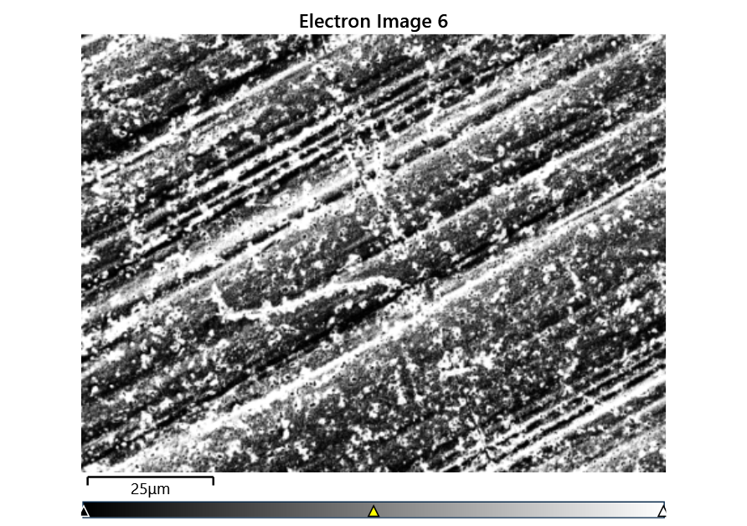



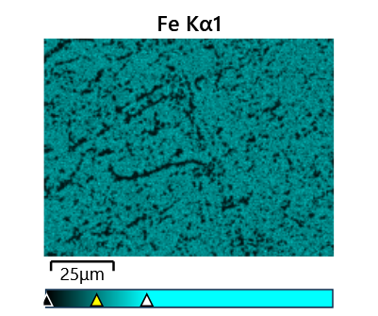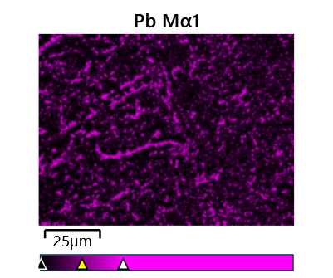

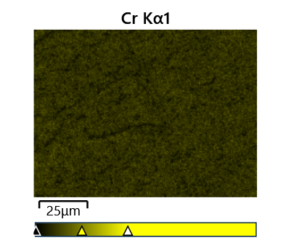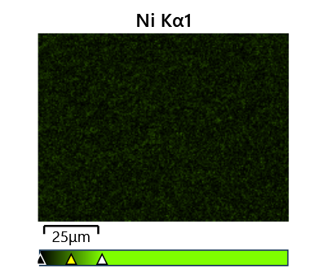

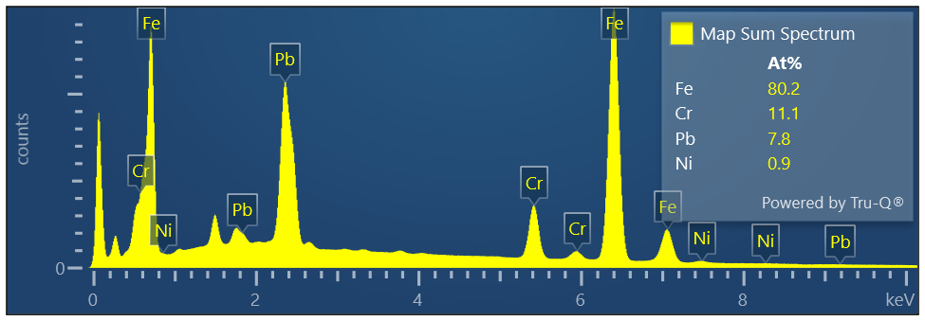

Map Sum Spectrum

Element Signal Weight % σ

Fe 66.63 0.06

Pb 23.97 0.05

Cr 8.59 0.03

Ni 0.81 0.03

**Map Sum Spectrum**

**Element Signal Atomic % σ**

**Fe 80.19**

**Cr 11.10**

**Pb 7.77**

**Ni 0.93**